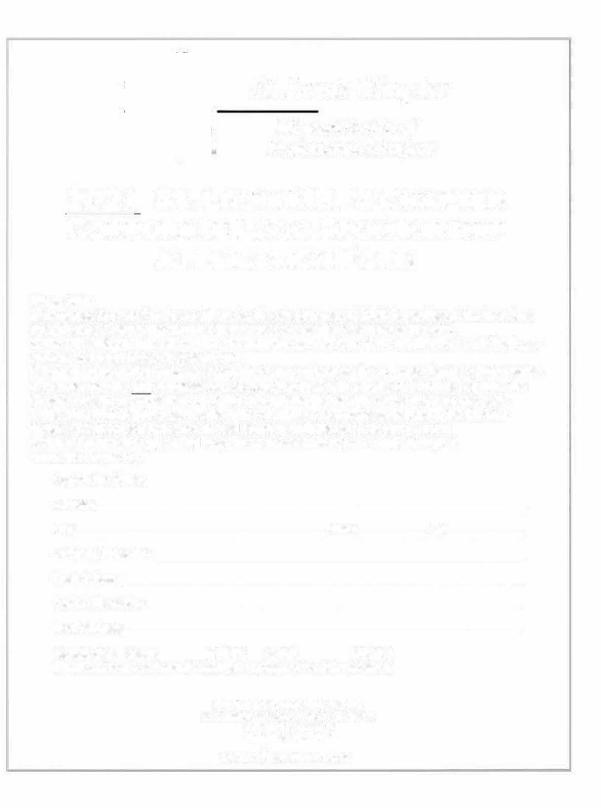
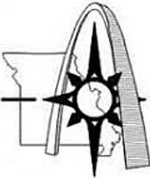
St. Louis Chapter
Missouri Society o.f Professional Surveyors

2022 ST. LOUIS MSPS CHAPTER CORPORATE LOGO SPONSORSHIP APPLICATION FORM

Please Note:
- Corporate Sponsorship dues paid are for the calendar year of 2022. Regardless of the logo dues date, dues paid within the current calendar year are for the remainder of the year.
- The STL MSPS Chapter may remove the corporate sponsor logo at the beginning of each year if sponsorship payment is not renewed.
- You may pay for the sponsorship amount with a credit card (via PayPal) from the Chapter website or by check to STL-MSPS through the address below.
- The STL MSPS Chapter reserves the right to remove or deny a sponsorship. If removed, that party may be eligible for a partial refund.
- Please email a clear JPG, PDF or DWG file of your Company logo to webmaster@stlsurveyor.org.
Corporation Name: _ Address: City: State: Zip: Company Phone No.: _ Contact Name: _
Contact Phone No.: _
Email Address: _ Check Box for Sponsorship Level if Enclosing a Check, otherwise payments can be made via PayPal at www.stlsurveyor.org/application/:
Website Logo $50.00 [ ] Half Target $200.00 [ ] Full Target $400.00 [ ] Other Amount $__________
ST. LOUIS CHAPTER MSPS
P.O. Box 4372 Chesterfield, MO 63006
www.stlsurveyor.org

