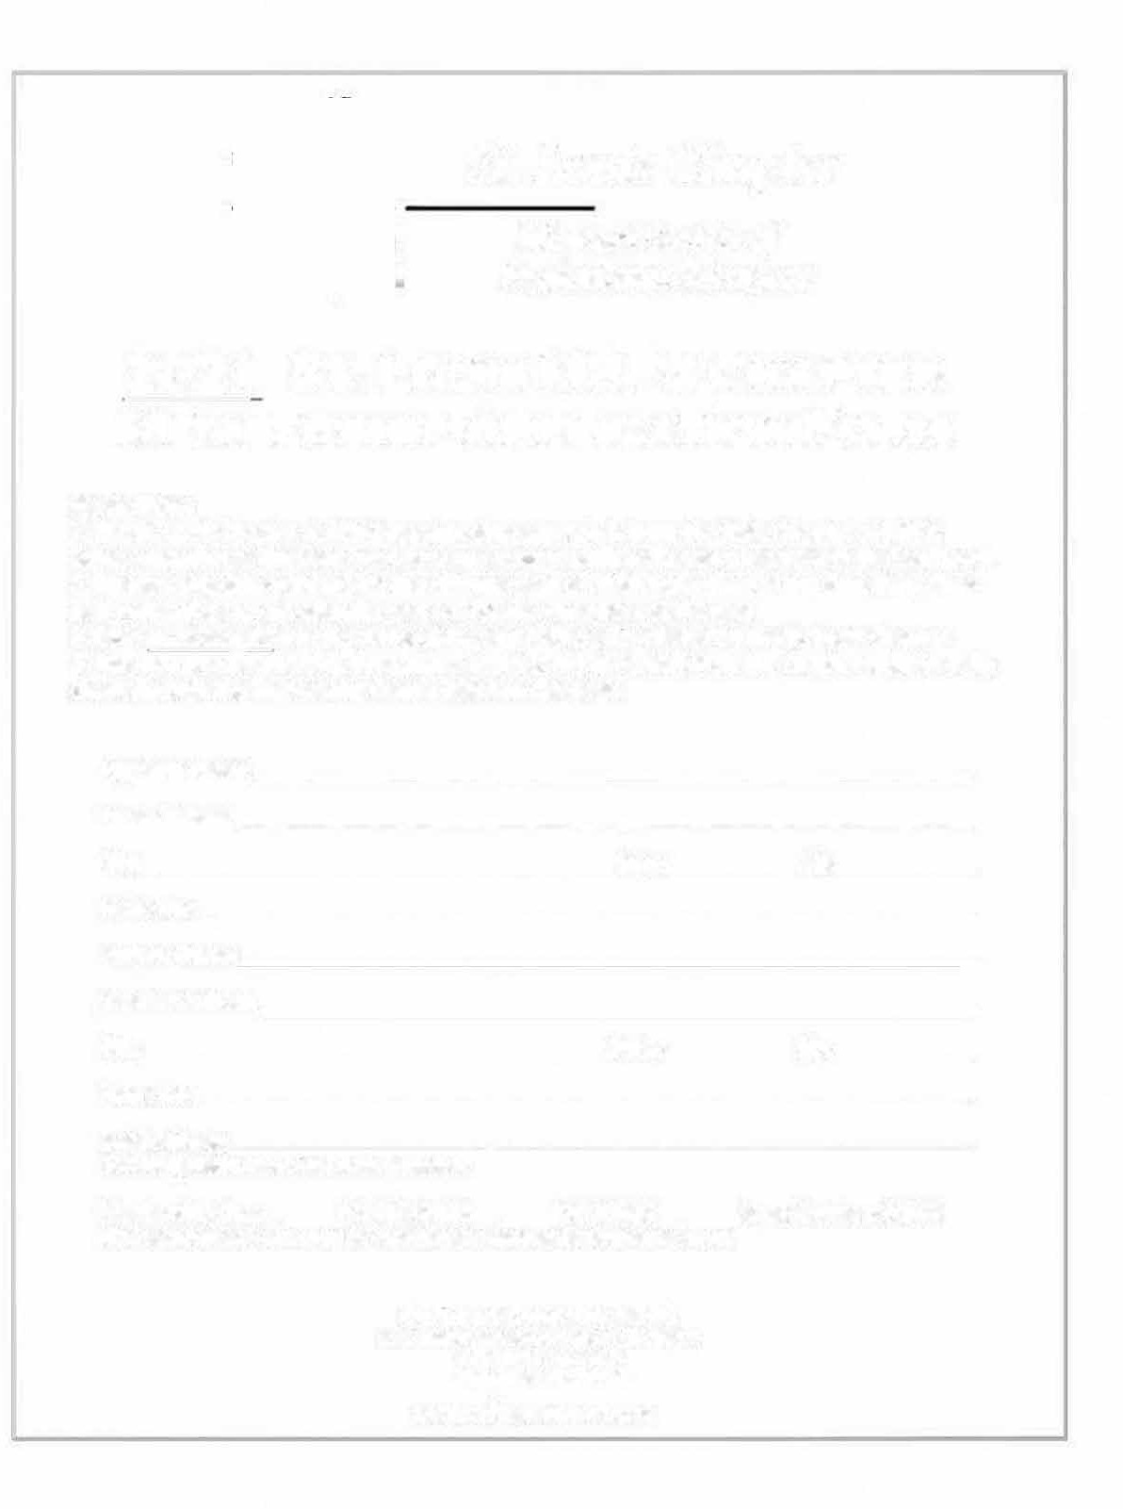St. Louis Chapter
Missouri Society o.f Professional Surveyors

2022 ST. LOUIS MSPS CHAPTER MEMBERSHIP APPLICATION FORM
Please Note:
- The St. Louis Chapter of MSPS receives dues separately from the State Chapter of MSPS. Being a member at the state level does not automatically make you a member at the local level.
- Membership dues paid are for the calendar year of 2022. Regardless of the dues date, dues paid within the current calendar year are for the remainder of the year.
- Dues must be paid for prior to receiving any POU credits offered by the St. Louis Chapter.
- You may pay membership dues with a credit card (via PayPal) from the Chapter website or by check through the Engineering Center listed on this page.

Applicant Name: Home Address: _ City: State: Zip: Phone No.: Business Name: _
Business Address:. _ City: State: Zip: _
Phone No.:
Email Address: _
You can provide more that one if needed.
Membership Class: __MO PLS $30.00 __LS1T $15.00 __Assoc./Business $15.00 (Please select one and provide appropriate payment to addresses listed)

ST. LOUIS CHAPTER MSPS
P.O. Box 4372 Chesterfield, MO 63006
www.sllsurveyor.org

