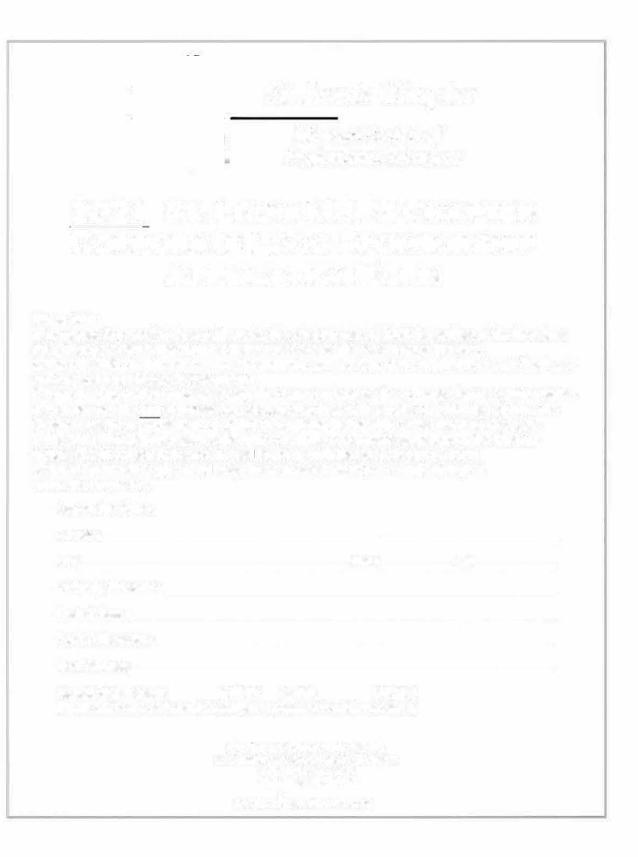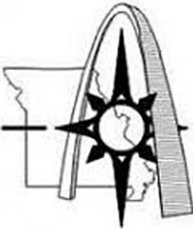St. Louis Chapter
Missouri Society o.f Professional Surveyors

2022 ST. LOUIS MSPS CHAPTER CORPORATE LOGO SPONSORSHIP APPLICATION FORM

Please Note:
- Corporate Sponsorship dues paid are for the calendar year of 2022. Regardless of the logo dues date, dues paid within the current calendar year are for the remainder of the year.
- The STL MSPS Chapter will remove the corporate sponsor logo at the beginning of each fiscal year and reinstall it upon logo dues payment.
- Dues must be paid for prior to placing the Corporate logo on the St. Louis Chapter MSPS website.
- You may pay the $50 corporate logo sponsorship dues with a credit card (via PayPal) from the Chapter website or by check to STL-MSPS through the Engineering Center listed on this page.
- The STL MSPS Chapter reserves the right to remove a corporate sponsor from the Chapter website if said corporation is not in good standing with the local Chapter By-Laws.
- Please email a clear jpg and pdf copy or an Autocad file of your Company logo to www.stlsurveyor.org.
Corporation Name: _ Address: City:� State: Zip: Company Phone No.: _ Contact Name: _
Contact Phone No.: _
Email Address: _ Membership: Check: ($50.00) PayPal:_ _ ($50.00)
(Please select one and provide appropriate payment to addresses listed)

ST. LOUIS CHAPTER MSPS
P.O. Box 4372 Chesterfield, MO 63006

www.sllsurveyor.org

